Top Base of a Cylinder
# Source: AI Source: Provided by: [Data Path: Persons Table -> ID Column: 1, Name_En Column: Motasem Essam] -> From: [ChatGPT] on [7/25/2026]
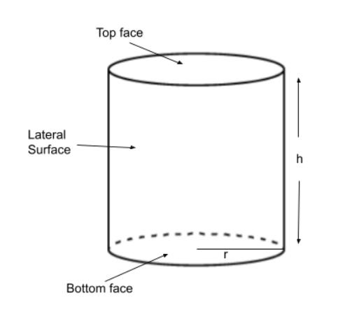
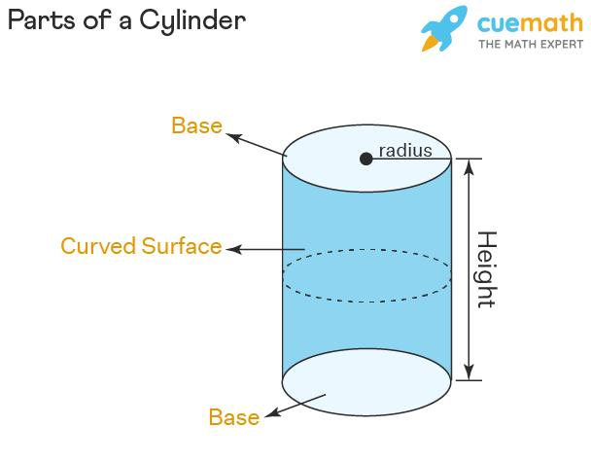


Definition
# Source: AI Source: Provided by: [Data Path: Persons Table -> ID Column: 1, Name_En Column: Motasem Essam] -> From: [ChatGPT] on [7/25/2026]
The top base of a cylinder is the flat face at the upper end of the cylinder. In a right circular cylinder, it is a circular region parallel and congruent to the bottom base.
The top base is one of the two bases of a cylinder. Its radius is equal to the radius of the bottom base, and the perpendicular distance between the two bases is the cylinder's height.
For a right circular cylinder, both bases have the same area:
$$A_{\text{top}}=A_{\text{bottom}}=πr^{2}$$

Simple Definition
# Source: AI Source: Provided by: [Data Path: Persons Table -> ID Column: 1, Name_En Column: Motasem Essam] -> From: [ChatGPT] on [7/25/2026]
The top base is the flat circular face on the top of a cylinder, like the circular top of a can.

Geometric Representation and Components
# Source: AI Source: Provided by: [Data Path: Persons Table -> ID Column: 1, Name_En Column: Motasem Essam] -> From: [ChatGPT] on [7/25/2026]
- Top base: The upper circular face.
- Center of the top base: The center point of its circular region.
- Radius ($r$): The distance from the center of the top base to its circular boundary.
- Diameter ($d$): A segment across the top base passing through its center, with $d=2r$.
- Circular boundary: The circumference separating the top base from the curved lateral surface.
- Base plane: The plane containing the top circular face.
- Height ($h$): The perpendicular distance between the top and bottom base planes.

Key Characteristics
# Source: AI Source: Provided by: [Data Path: Persons Table -> ID Column: 1, Name_En Column: Motasem Essam] -> From: [ChatGPT] on [7/25/2026]
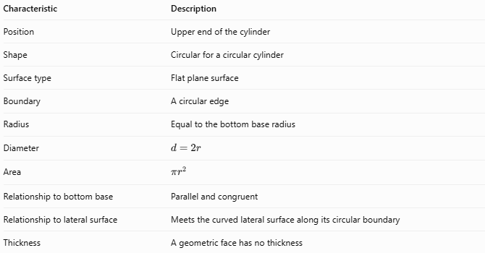
Characteristic | Description
Position | Upper end of the cylinder
Shape | Circular for a circular cylinder
Surface type | Flat plane surface
Boundary | A circular edge
Radius | Equal to the bottom base radius
Diameter | $$d=2r$$
Area | $$πr^{2}$$
Relationship to bottom base | Parallel and congruent
Relationship to lateral surface | Meets the curved lateral surface along its circular boundary
Thickness | A geometric face has no thickness
Note: In an oblique cylinder, the top and bottom bases are still parallel and congruent. However, the cylinder's axis is inclined relative to the base planes.

Mathematical Formulas

Area of the Top Base
# Source: AI Source: Provided by: [Data Path: Persons Table -> ID Column: 1, Name_En Column: Motasem Essam] -> From: [ChatGPT] on [7/25/2026]
For a circular cylinder:
$$\boxed{A_{\text{top}}=πr^{2}}$$
Where $r$ is the radius of the top circular base.

Area Using the Diameter
# Source: AI Source: Provided by: [Data Path: Persons Table -> ID Column: 1, Name_En Column: Motasem Essam] -> From: [ChatGPT] on [7/25/2026]
Since $r=d/2$:
$$\boxed{A_{\text{top}}=\frac{πd^{2}}{4}}$$

Circumference of the Top Base
# Source: AI Source: Provided by: [Data Path: Persons Table -> ID Column: 1, Name_En Column: Motasem Essam] -> From: [ChatGPT] on [7/25/2026]
$$\boxed{C_{\text{top}}=2πr=πd}$$

Relationship to the Cylinder's Total Surface Area
# Source: AI Source: Provided by: [Data Path: Persons Table -> ID Column: 1, Name_En Column: Motasem Essam] -> From: [ChatGPT] on [7/25/2026]
For a right circular cylinder:
$$A_{\text{total}}=2πrh+2πr^{2}$$
The two bases together have area:
$$A_{\text{two bases}}=2πr^{2}$$
Therefore, the top base contributes one circular area of $πr^{2}$ to the total surface area.

Worked Examples
# Source: AI Source: Provided by: [Data Path: Persons Table -> ID Column: 1, Name_En Column: Motasem Essam] -> From: [ChatGPT] on [7/25/2026]
Example 1 — Calculate the Top Base Area
A cylindrical container has a top base with radius $5\text{ cm}$. Find its area.
Solution
$$A_{\text{top}}=πr^{2}$$
$$A_{\text{top}}=π{\left(5\right)}^{2}=25π$$
Answer:
$$\boxed{A_{\text{top}}≈78.54{\text{ cm}}^{2}}$$
Example 2 — Calculate the Area from the Diameter
The diameter of a cylinder's top base is $12\text{ cm}$. Find the area.
Solution
First, calculate the radius:
$$r=\frac{12}{2}=6\text{ cm}$$
Then calculate the area:
$$A_{\text{top}}=π{\left(6\right)}^{2}$$
$$\boxed{A_{\text{top}}=36π≈113.10{\text{ cm}}^{2}}$$
Example 3 — Calculate the Total Area of Both Bases
A cylinder has a radius of $4\text{ cm}$. Find the combined area of its top and bottom bases.
$$A_{\text{two bases}}=2πr^{2}$$
$$A_{\text{two bases}}=2π{\left(4\right)}^{2}$$
$$\boxed{A_{\text{two bases}}=32π≈100.53{\text{ cm}}^{2}}$$
The top base alone has half this area:
$$A_{\text{top}}=16π≈50.27{\text{ cm}}^{2}$$

Comparison with Related Cylinder Components
# Source: AI Source: Provided by: [Data Path: Persons Table -> ID Column: 1, Name_En Column: Motasem Essam] -> From: [ChatGPT] on [7/25/2026]
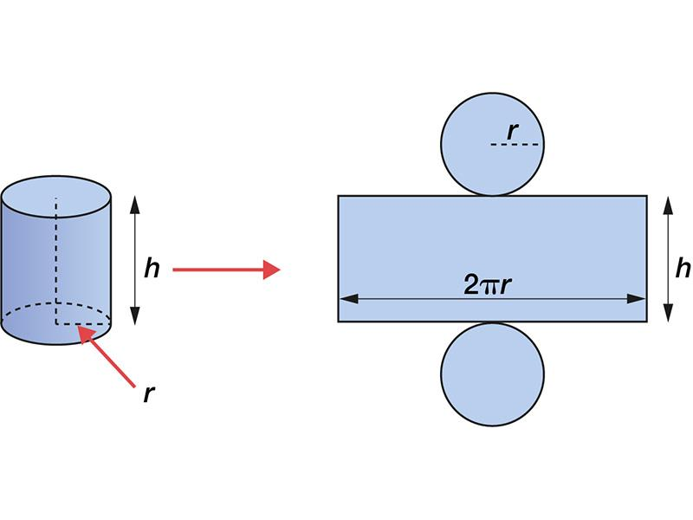
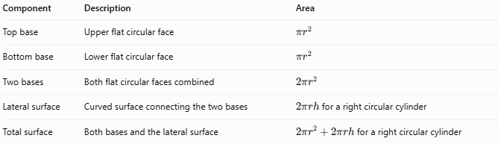
Component | Description | Area
Top base | Upper flat circular face | $$πr^{2}$$
Bottom base | Lower flat circular face | $$πr^{2}$$
Two bases | Both flat circular faces combined | $$2πr^{2}$$
Lateral surface | Curved surface connecting the two bases | $2πrh$ for a right circular cylinder
Total surface | Both bases and the lateral surface | $2πr^{2}+2πrh$ for a right circular cylinder

Applications
# Source: AI Source: Provided by: [Data Path: Persons Table -> ID Column: 1, Name_En Column: Motasem Essam] -> From: [ChatGPT] on [7/25/2026]
- Containers: The top face of a can, cylindrical jar, or closed tank.
- Engineering: The upper circular face of a cylindrical component.
- Manufacturing: A reference surface for measuring a cylinder's diameter and flatness.
- Geometry: Calculating circular areas and understanding the structure of three-dimensional solids.
- Packaging: Estimating the area needed for a circular lid.

Key Points
# Source: AI Source: Provided by: [Data Path: Persons Table -> ID Column: 1, Name_En Column: Motasem Essam] -> From: [ChatGPT] on [7/25/2026]
- The top base is the upper flat face of a cylinder.
- For a circular cylinder, it is a circle bounded by a circular edge.
- Its area is $πr^{2}$.
- Its circumference is $2πr$.
- It is parallel and congruent to the bottom base.
- Its area is independent of the cylinder's height.
- The top base is distinct from the cylinder's curved lateral surface.

Conclusion
# Source: AI Source: Provided by: [Data Path: Persons Table -> ID Column: 1, Name_En Column: Motasem Essam] -> From: [ChatGPT] on [7/25/2026]
The top base of a cylinder is its upper flat circular face. It has the same radius and area as the bottom base, and its area is calculated using $πr^{2}$. Understanding the top base helps when calculating the cylinder's base area, total surface area, and other geometric measurements.

